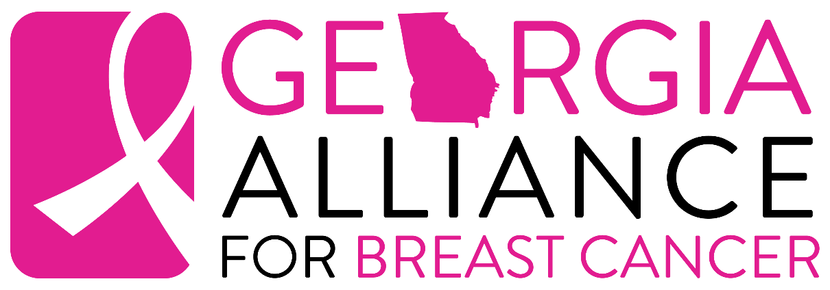

Dear ___________,

I will be participating in a very special and powerful event in the fight against breast cancer. It is called the Georgia 2-Day Walk for Breast Cancer produced by Georgia Alliance for Breast Cancer and I would like to tell you about it.

Along with hundreds of others, I will spend two days walking 30 miles around metro-Atlanta – a formidable challenge! We’ve taken on the challenge to raise funds for life-saving breast health and breast cancer programs here in Georgia.

Breast cancer is the most common form of cancer in women in the United States and the leading cause of death in women between the ages of 40 and 55. The need for education and early detection is unquestionable. Currently, one million women in the United States have the disease and don’t know it. All of us – wives, mothers, daughters, sisters, and men– face the possibility of having to deal with this deadly disease in some way, at some time, in our lifetime. I walk for my survivor, __________.

… TELL SURVIVOR’S STORY HERE …

In order to participate in this event, I have agreed to raise a minimum of $1,200 in donations as my contribution to the Georgia 2-Day Walk for Breast Cancer. I am asking for your help to meet my goal, or better yet, to exceed it! Would you please consider making a tax-deductible donation? I’ve enclosed a donation form along - please write a check payable to “Georgia
2-Day Walk for Breast Cancer” or “Georgia Alliance for Breast Cancer” and return it as soon as possible. If you know anyone who might also be interested in supporting our cause, please feel free to pass on copies of my letter and pledge form. I can also send them copies if you give me their address.

I’ll do the walking and, in partnership, we will do our part in the battle against breast cancer. If you have any questions, please call me at ______________ or e-mail me at __________________.

Thank you in advance for your generosity and support.

Sincerely,

