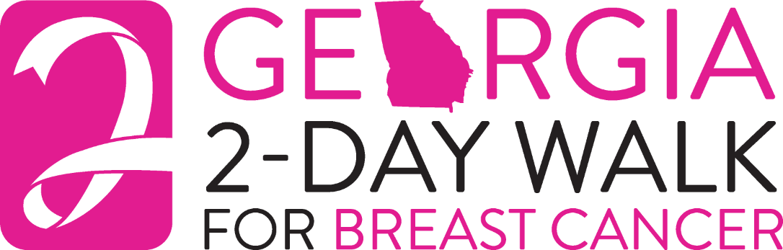

Dear _______,

30 miles in 2 days! Walking!

This year, along with hundreds of others, I will lace up my walking shoes and join the Georgia
2-Day Walk for Breast Cancer. We’ve taken on the challenge of making this trek to raise funds for Georgia breast health and breast cancer programs. We will spend 2 days walking 30 miles through metro Atlanta – a formidable challenge!

Breast cancer is the second leading cause of cancer death for all women and the leading cause of death in women between the ages of 40 and 55. The need for education and early detection is unquestionable – currently, 1 in 8 women will be diagnosed with breast cancer this year alone. I have a personal interest in this – my ________ was diagnosed with breast cancer and my ________ was a survivor. All of us – wives, mothers, daughters, sisters, and the men in our lives – face the possibility of having to deal with this deadly disease in some way, at some time, in our lifetime. That’s why I have taken on this challenge- to be a part of something that will affect the lives of people I will never meet…to truly make a difference.

In order to participate in this event, I have agreed to raise a minimum of $1,200 in donations as my contribution to the Georgia 2-Day Walk for Breast Cancer. I am asking for your help to meet my goal, or better yet, to exceed it! Would you please consider making a tax-deductible donation for this cause? I’ve enclosed a donation form - please write a check payable to “Georgia 2-Day Walk for Breast Cancer” or “Georgia Alliance for Breast Cancer” and return it as soon as possible. Should you know anyone who might be interested in supporting our cause, please feel free to pass on copies of my letter and donation form.

To make a donation online, please go to www.gaabc.org and click : Donate Now / Donate to a 2025 Walker or Crew Member / Donate
Then, please complete the form, and submit my name at the bottom!

Please help me with your contribution; I’ll do the walking and in partnership, we will do our part in the battle against breast cancer. If you have any questions, please call me at __________ or email: _____________

On behalf of the millions of women and men I am walking for, thank you for your generosity.

Sincerely,

