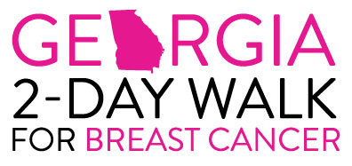

Dear _______,

30 miles in 2 days! Walking!

This year, along with hundreds of others, I will lace up my walking shoes and join the Georgia 2-Day Walk for Breast Cancer. We’ve taken on the challenge of making this trek to raise funds for Georgia breast health and breast cancer programs. We will spend 2 days walking 30 miles through metro Atlanta – a formidable challenge!

Breast cancer is the second leading cause of cancer death for all women and the leading cause of death in women between the ages of 40 and 55. The need for education and early detection is unquestionable – currently, 1 in 8 women will be diagnosed with breast cancer in this year alone. I have a personal interest in this – my _____ was diagnosed with breast cancer and my ______ was a survivor. All of us – wives, mothers, daughters, sisters, and the men in our lives – face the possibility of having to deal with this deadly disease in some way, at some time, in our lifetime. That’s why I have taken on this challenge- to be a part of something that will affect the lives of people I will never meet…to truly make a difference.

In order to participate in this event, I have agreed to raise a minimum of $1,000 in donations as my contribution to the Georgia 2-Day Walk for Breast Cancer. I am asking for your help to meet my goal, or better yet, to exceed it! Would you please consider making a tax-deductible donation for this cause? I’ve enclosed a donation form - please write a check payable to “Georgia 2-Day Walk for Breast Cancer” or “It’s The Journey” and return it as soon as possible. Should you know anyone who might be interested in supporting our cause, please feel free to pass on copies of my letter and donation form.

To make a donation online, please go to www.2daywalk.org and click “Donate Now” and then follow the links to find my personal donation page.

Please help me with your contribution; I’ll do the walking and in partnership we will do our part in the battle against breast cancer. If you have any questions, please call me at ________ or email: ___________

On behalf of the millions of women and men I am walking for, thank you for your generosity.

Sincerely,

