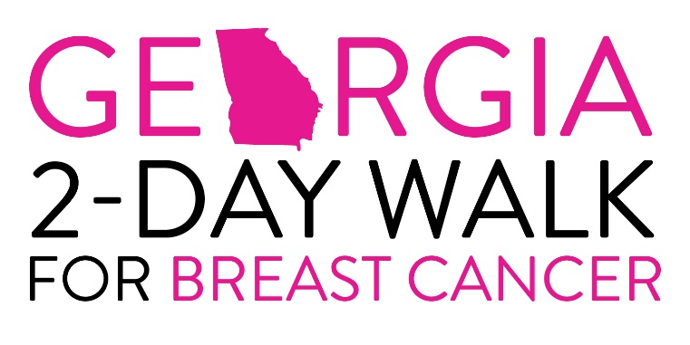

Dear ___________,

I’m on track to accomplish a major goal - walking in the Georgia 2-Day Walk for Breast Cancer! I will join hundreds of others who will be walking a total of 30 miles over two days. I’m so excited to be a part of this experience, and to be a part of such an incredible community, each of us doing our part to make a big difference in the lives of our fellow Georgians affected by breast cancer!

One out of every 8 women in America will develop breast cancer in her lifetime, and over 1 million women are living with this undetected cancer now. The stats go on and on. The encouraging news is over two million survivors are alive today, and early detection increases the odds for survival dramatically.

Won’t you help me stomp out breast cancer? Your part requires no special equipment or training. But it does require your generous 100% tax-deductible donation. In order to participate in this event, it is required that I raise a minimum of $1000 in donations. Imagine how much help your contribution can mean to the lives of women, men, and families around Georgia!

I have enclosed a donation form. I would love to answer any questions you might have- feel free to contact me by email or phone!

I am blessed to not personally have battled breast cancer, and am therefore grateful that my health affords me the chance to walk in the Georgia 2-Day Walk for Breast Cancer. Please join me and become a part of fulfilling this ambitious goal!

Thankfully,

